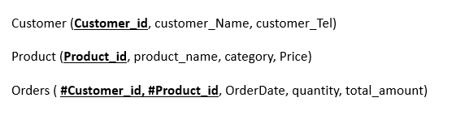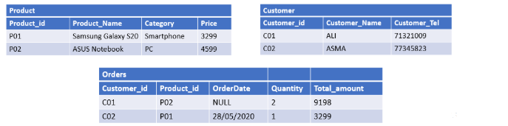
- INSERT INTO CUSTOMER
VALUES
(‘C01’, ‘ALI’, 71321009),
(‘C02’, ‘ASMA’,77345823);

- INSERT INTO PRODUCT (Product_id, Product_Name, Category, Price)
VALUES
(‘P01’, ‘Samsung Galaxy S20’, ‘Smartphone’, 3299),
(‘P02’, ‘ASUS Notebook’, ‘PC’, 4599);

- INSERT INTO ORDERS (Customer_id, Product_id, OrderDate, Quantity, Total_Amount)
VALUES
(‘C01’, ‘P02’, NULL, 2, 9198),
(‘C02’, ‘P01’, ‘2020-05-28’, 1,3299);

